Problem Set 8

*Prateek Kumar*

Contents

Problem 1: Orthogonal Designs 2

Create one that is orthogonal to the two existing IVs, and verify that it is orthogonal 2

Which of the following grouping variables are both orthogonal and uncorrelated with both feedback and train? 3

Problem 2: Regression with orthogonal and uncorrelated predictors 7

Do the coefficients differ across models (including intercept)? 7

Does the coefficient differ across models with the orthogonal predictors? 9

When the first observation is missing 11

Problem 3. Modeling a time series. 15

A. Loess regression 15

B. Polynomial regression 19

C. Adding month predictor 23

# Problem 1: Orthogonal Designs

training <- rep(c(1,1,1,0,0,0,-1,-1,-1),each=3)  
training

## [1] 1 1 1 1 1 1 1 1 1 0 0 0 0 0 0 0 0 0 -1 -1 -1 -1 -1  
## [24] -1 -1 -1 -1

feedback <- rep(c(1,0,-1,1,0,-1,1,0,-1),each=3)  
feedback

## [1] 1 1 1 0 0 0 -1 -1 -1 1 1 1 0 0 0 -1 -1 -1 1 1 1 0 0  
## [24] 0 -1 -1 -1

We have two 3-level independent variables:

* training (no training, standard training, interactive training)
* feedback (no feedback, feedback on errors, feedback on correct)

Correlation between training and feedback

cor(training, feedback)

## [1] 0

Dot product between training and feedback

training %*% feedback

## [,1]  
## [1,] 0

We can verify that both of them are uncorrelated and orthogonal since their correlation and dot product is zero.

## Create one that is orthogonal to the two existing IVs, and verify that it is orthogonal

group <- rep(c(1,-1,0,-1,0,1,0,1,-1),each=3)  
group

## [1] 1 1 1 -1 -1 -1 0 0 0 -1 -1 -1 0 0 0 1 1 1 0 0 0 1 1  
## [24] 1 -1 -1 -1

Here the above IV “group” is both uncorrelated and orthogonal to both training and feedback, which we verified below

Correlation between training and group

cor(training, group)

## [1] 0

Dot product between training and group

training %*% group

## [,1]  
## [1,] 0

Its orthogonal and uncorrelated with training

Correlation between feedback and group

cor(feedback, group)

## [1] 0

Dot product between feedback and group

feedback %*% group

## [,1]  
## [1,] 0

Its orthogonal and uncorrelated with feedback as well.

## Which of the following grouping variables are both orthogonal and uncorrelated with both feedback and train?

set.seed(100)  
group1 <- 1:27  
group2 <- rep(-1:1, 9)  
group3 <- 1:27-mean(1:27)  
group4 <- rep(1:3, 9)  
group5 <- rep(-1:1,each=9)  
group6 <- runif(27)-.5  
group7 <- rep(1:9,each=3)

We will calculate the correlation and dot product of each group IV with training and feedback

Firstly, calculating with training:

Correlation between training and group1

cor(training, group1)

## [1] -0.9434564

Dot product between training and group1

training %*% group1

## [,1]  
## [1,] -162

Correlation between training and group2

cor(training, group2)

## [1] 0

Dot product between training and group2

training %*% group2

## [,1]  
## [1,] 0

Correlation between training and group3

cor(training, group3)

## [1] -0.9434564

Dot product between training and group3

training %*% group3

## [,1]  
## [1,] -162

Correlation between training and group4

cor(training, group4)

## [1] 0

Dot product between training and group4

training %*% group4

## [,1]  
## [1,] 0

Correlation between training and group5

cor(training, group5)

## [1] -1

Dot product between training and group5

training %*% group5

## [,1]  
## [1,] -18

Correlation between training and group6

cor(training, group6)

## [1] -0.2257106

Dot product between training and group6

training %*% group6

## [,1]  
## [1,] -1.089779

Correlation between training and group7

cor(training, group7)

## [1] -0.9486833

Dot product between training and group7

training %*% group7

## [,1]  
## [1,] -54

We see that only group2 and group4 are uncorrelated and orthogonal with training because the correlation and dot product is zero in this case

Now calculating with feedback

Correlation between feedback and group1

cor(feedback, group1)

## [1] -0.3144855

Dot product between feedback and group1

feedback %*% group1

## [,1]  
## [1,] -54

Correlation between feedback and group2

cor(feedback, group2)

## [1] 0

Dot product between feedback and group2

feedback %*% group2

## [,1]  
## [1,] 0

Correlation between feedback and group3

cor(feedback, group3)

## [1] -0.3144855

Dot product between feedback and group3

feedback %*% group3

## [,1]  
## [1,] -54

Correlation between feedback and group4

cor(feedback, group4)

## [1] 0

Dot product between feedback and group4

feedback %*% group4

## [,1]  
## [1,] 0

Correlation between feedback and group5

cor(feedback, group5)

## [1] 0

Dot product between feedback and group5

feedback %*% group5

## [,1]  
## [1,] 0

Correlation between feedback and group6

cor(feedback, group6)

## [1] 0.0121159

Dot product between feedback and group6

feedback %*% group6

## [,1]  
## [1,] 0.05849814

Correlation between feedback and group7

cor(feedback, group7)

## [1] -0.3162278

Dot product between feedback and group7

feedback %*% group7

## [,1]  
## [1,] -18

We see that group2, group4 and group5 are uncorrelated and orthogonal with feedback because the correlation and dot product is zero in this case

So we conclude from the above results that only group2 and group4 are uncorrelated and orthogonal with both training and feedback.

# Problem 2: Regression with orthogonal and uncorrelated predictors

data <- data.frame(buyerid = group7,  
 timeframe=group4)  
  
set.seed(103)  
  
buyerbase <- runif(9)  
timebase <- c(1,2,2.5)  
agebase <- 20+runif(9)* 40  
  
data$age <- round(agebase[data$buyerid])  
data$purchase <- round( 25 + buyerbase[data$buyerid] * 50 +  
 data$age * .5+   
 timebase[data$timeframe] * 7 +  
 rnorm(27)*4,2)

Creating the dataset from above code

## Do the coefficients differ across models (including intercept)?

Creating a regression model to predict purchase amount by timeframe and age and checking the coefficients

lm(purchase ~ timeframe+age, data = data)$coef

## (Intercept) timeframe age   
## 46.3220369 5.3900000 0.3200048

summary(lm(purchase ~ timeframe+age, data = data))

##   
## Call:  
## lm(formula = purchase ~ timeframe + age, data = data)  
##   
## Residuals:  
## Min 1Q Median 3Q Max   
## -15.382 -9.357 -3.122 9.808 19.608   
##   
## Coefficients:  
## Estimate Std. Error t value Pr(>|t|)   
## (Intercept) 46.3220 8.9654 5.167 2.73e-05 ***  
## timeframe 5.3900 2.5544 2.110 0.0455 *   
## age 0.3200 0.1849 1.731 0.0963 .   
## ---  
## Signif. codes: 0 '***' 0.001 '**' 0.01 '*' 0.05 '.' 0.1 ' ' 1  
##   
## Residual standard error: 10.84 on 24 degrees of freedom  
## Multiple R-squared: 0.2369, Adjusted R-squared: 0.1733   
## F-statistic: 3.724 on 2 and 24 DF, p-value: 0.03902

Creating a regression model to predict purchase amount by timeframe only and checking the coefficients

lm(purchase ~ timeframe, data = data)$coef

## (Intercept) timeframe   
## 58.55333 5.39000

summary(lm(purchase ~ timeframe, data = data))

##   
## Call:  
## lm(formula = purchase ~ timeframe, data = data)  
##   
## Residuals:  
## Min 1Q Median 3Q Max   
## -17.693 -6.978 -2.393 6.537 24.017   
##   
## Coefficients:  
## Estimate Std. Error t value Pr(>|t|)   
## (Intercept) 58.553 5.734 10.211 2.1e-10 ***  
## timeframe 5.390 2.654 2.031 0.0531 .   
## ---  
## Signif. codes: 0 '***' 0.001 '**' 0.01 '*' 0.05 '.' 0.1 ' ' 1  
##   
## Residual standard error: 11.26 on 25 degrees of freedom  
## Multiple R-squared: 0.1416, Adjusted R-squared: 0.1072   
## F-statistic: 4.123 on 1 and 25 DF, p-value: 0.05307

Creating a regression model to predict purchase amount by age only and checking the coefficients

lm(purchase ~ age, data = data)$coef

## (Intercept) age   
## 57.1020369 0.3200048

summary(lm(purchase ~ age, data = data))

##   
## Call:  
## lm(formula = purchase ~ age, data = data)  
##   
## Residuals:  
## Min 1Q Median 3Q Max   
## -16.2322 -9.1772 -0.9822 7.1678 23.6577   
##   
## Coefficients:  
## Estimate Std. Error t value Pr(>|t|)   
## (Intercept) 57.1020 7.8597 7.265 1.3e-07 ***  
## age 0.3200 0.1972 1.623 0.117   
## ---  
## Signif. codes: 0 '***' 0.001 '**' 0.01 '*' 0.05 '.' 0.1 ' ' 1  
##   
## Residual standard error: 11.56 on 25 degrees of freedom  
## Multiple R-squared: 0.09528, Adjusted R-squared: 0.05909   
## F-statistic: 2.633 on 1 and 25 DF, p-value: 0.1172

We see from the above results that the β values are same when we calculate the regression with both predictors together and individually (timeframe and age) i.e. 5.39 and 0.32 respectively but the intercept values differ in all the 3 cases.

## Does the coefficient differ across models with the orthogonal predictors?

Now transforming the predictors to orthogonal

age1 <- data$age-mean(data$age)  
tf1 <- data$timeframe-mean(data$timeframe)

Checking the coefficients with both the new predictors together

lm(purchase ~ tf1+age1, data = data)$coef

## (Intercept) tf1 age1   
## 69.3333333 5.3900000 0.3200048

summary(lm(purchase ~ tf1+age1, data = data))

##   
## Call:  
## lm(formula = purchase ~ tf1 + age1, data = data)  
##   
## Residuals:  
## Min 1Q Median 3Q Max   
## -15.382 -9.357 -3.122 9.808 19.608   
##   
## Coefficients:  
## Estimate Std. Error t value Pr(>|t|)   
## (Intercept) 69.3333 2.0857 33.243 <2e-16 ***  
## tf1 5.3900 2.5544 2.110 0.0455 *   
## age1 0.3200 0.1849 1.731 0.0963 .   
## ---  
## Signif. codes: 0 '***' 0.001 '**' 0.01 '*' 0.05 '.' 0.1 ' ' 1  
##   
## Residual standard error: 10.84 on 24 degrees of freedom  
## Multiple R-squared: 0.2369, Adjusted R-squared: 0.1733   
## F-statistic: 3.724 on 2 and 24 DF, p-value: 0.03902

Creating a regression model to predict purchase amount by orthogonal timeframe only and checking the coefficients

lm(purchase ~ tf1, data = data)$coef

## (Intercept) tf1   
## 69.33333 5.39000

summary(lm(purchase ~ tf1, data = data))

##   
## Call:  
## lm(formula = purchase ~ tf1, data = data)  
##   
## Residuals:  
## Min 1Q Median 3Q Max   
## -17.693 -6.978 -2.393 6.537 24.017   
##   
## Coefficients:  
## Estimate Std. Error t value Pr(>|t|)   
## (Intercept) 69.333 2.167 31.990 <2e-16 ***  
## tf1 5.390 2.654 2.031 0.0531 .   
## ---  
## Signif. codes: 0 '***' 0.001 '**' 0.01 '*' 0.05 '.' 0.1 ' ' 1  
##   
## Residual standard error: 11.26 on 25 degrees of freedom  
## Multiple R-squared: 0.1416, Adjusted R-squared: 0.1072   
## F-statistic: 4.123 on 1 and 25 DF, p-value: 0.05307

Creating a regression model to predict purchase amount by orthogonal age only and checking the coefficients

lm(purchase ~ age1, data = data)$coef

## (Intercept) age1   
## 69.3333333 0.3200048

summary(lm(purchase ~ age1, data = data))

##   
## Call:  
## lm(formula = purchase ~ age1, data = data)  
##   
## Residuals:  
## Min 1Q Median 3Q Max   
## -16.2322 -9.1772 -0.9822 7.1678 23.6577   
##   
## Coefficients:  
## Estimate Std. Error t value Pr(>|t|)   
## (Intercept) 69.3333 2.2250 31.161 <2e-16 ***  
## age1 0.3200 0.1972 1.623 0.117   
## ---  
## Signif. codes: 0 '***' 0.001 '**' 0.01 '*' 0.05 '.' 0.1 ' ' 1  
##   
## Residual standard error: 11.56 on 25 degrees of freedom  
## Multiple R-squared: 0.09528, Adjusted R-squared: 0.05909   
## F-statistic: 2.633 on 1 and 25 DF, p-value: 0.1172

From the above results we see that even the intercepts remain unchanged along with the β values i.e. 69.33 for intercept and 5.39 and 0.32 for the orthogonal timeframe and age respectively, we can see the β values are same in both the cases. This happens because the predictors have been centered, and are both uncorrelated and orthogonal.

So, the advantage of having orthogonal predictors in a regression is that it won't matter if we add or remove any - our estimates won't change. Thus, when possible, using orthogonal predictors in regression make for stable predictors. This can usually only be achieved through designing an experiment - we are unlikely to get this by sampling all variables at random from a population. But even if we have some dependence between predictors, we may be able to achieve more stable predictors by centering the variables, and so that can be a good practice regardless, and it will often make for more interpretable models, as it fits a model around the center of the data

## When the first observation is missing

Removing the first observation

data2 <- data[-1,]

Checking the coefficients with the new dataset

Checking the coefficients with both the predictors together

lm(purchase ~ timeframe+age, data = data2)$coef

## (Intercept) timeframe age   
## 47.3474132 5.1137764 0.3124496

summary(lm(purchase ~ timeframe+age, data = data2))

##   
## Call:  
## lm(formula = purchase ~ timeframe + age, data = data2)  
##   
## Residuals:  
## Min 1Q Median 3Q Max   
## -15.345 -9.955 -3.176 9.959 19.528   
##   
## Coefficients:  
## Estimate Std. Error t value Pr(>|t|)   
## (Intercept) 47.3474 9.4319 5.020 4.44e-05 ***  
## timeframe 5.1138 2.6781 1.909 0.0688 .   
## age 0.3124 0.1889 1.654 0.1117   
## ---  
## Signif. codes: 0 '***' 0.001 '**' 0.01 '*' 0.05 '.' 0.1 ' ' 1  
##   
## Residual standard error: 11.03 on 23 degrees of freedom  
## Multiple R-squared: 0.2135, Adjusted R-squared: 0.1451   
## F-statistic: 3.121 on 2 and 23 DF, p-value: 0.06321

Creating a regression model to predict purchase amount by timeframe only and checking the coefficients

lm(purchase ~ timeframe, data = data2)$coef

## (Intercept) timeframe   
## 59.556327 5.013878

summary(lm(purchase ~ timeframe, data = data2))

##   
## Call:  
## lm(formula = purchase ~ timeframe, data = data2)  
##   
## Residuals:  
## Min 1Q Median 3Q Max   
## -17.568 -7.054 -0.656 6.130 23.766   
##   
## Coefficients:  
## Estimate Std. Error t value Pr(>|t|)   
## (Intercept) 59.556 6.079 9.797 7.33e-10 ***  
## timeframe 5.014 2.773 1.808 0.0831 .   
## ---  
## Signif. codes: 0 '***' 0.001 '**' 0.01 '*' 0.05 '.' 0.1 ' ' 1  
##   
## Residual standard error: 11.42 on 24 degrees of freedom  
## Multiple R-squared: 0.1199, Adjusted R-squared: 0.08325   
## F-statistic: 3.27 on 1 and 24 DF, p-value: 0.08309

Creating a regression model to predict purchase amount by age only and checking the coefficients

lm(purchase ~ age, data = data2)$coef

## (Intercept) age   
## 58.0842835 0.3043129

summary(lm(purchase ~ timeframe, data = data2))

##   
## Call:  
## lm(formula = purchase ~ timeframe, data = data2)  
##   
## Residuals:  
## Min 1Q Median 3Q Max   
## -17.568 -7.054 -0.656 6.130 23.766   
##   
## Coefficients:  
## Estimate Std. Error t value Pr(>|t|)   
## (Intercept) 59.556 6.079 9.797 7.33e-10 ***  
## timeframe 5.014 2.773 1.808 0.0831 .   
## ---  
## Signif. codes: 0 '***' 0.001 '**' 0.01 '*' 0.05 '.' 0.1 ' ' 1  
##   
## Residual standard error: 11.42 on 24 degrees of freedom  
## Multiple R-squared: 0.1199, Adjusted R-squared: 0.08325   
## F-statistic: 3.27 on 1 and 24 DF, p-value: 0.08309

We see that on removing the first row we get the different results. Now we can see that our β values are different when we calculate the regression with both timeframe and age together and when we calculate the regression with both timeframe and age individually.

Now transforming the predictors to orthogonal

age2 <- data2$age-mean(data2$age)  
tf2 <- data2$timeframe-mean(data2$timeframe)

Checking the coefficients with both the new predictors together

lm(purchase ~ tf2+age2, data = data2)$coef

## (Intercept) tf2 age2   
## 69.7769231 5.1137764 0.3124496

summary(lm(purchase ~ tf2+age2, data = data2))

##   
## Call:  
## lm(formula = purchase ~ tf2 + age2, data = data2)  
##   
## Residuals:  
## Min 1Q Median 3Q Max   
## -15.345 -9.955 -3.176 9.959 19.528   
##   
## Coefficients:  
## Estimate Std. Error t value Pr(>|t|)   
## (Intercept) 69.7769 2.1625 32.266 <2e-16 ***  
## tf2 5.1138 2.6781 1.909 0.0688 .   
## age2 0.3124 0.1889 1.654 0.1117   
## ---  
## Signif. codes: 0 '***' 0.001 '**' 0.01 '*' 0.05 '.' 0.1 ' ' 1  
##   
## Residual standard error: 11.03 on 23 degrees of freedom  
## Multiple R-squared: 0.2135, Adjusted R-squared: 0.1451   
## F-statistic: 3.121 on 2 and 23 DF, p-value: 0.06321

Creating a regression model to predict purchase amount by orthogonal timeframe only and checking the coefficients

lm(purchase ~ tf2, data = data2)$coef

## (Intercept) tf2   
## 69.776923 5.013878

summary(lm(purchase ~ tf2, data = data2))

##   
## Call:  
## lm(formula = purchase ~ tf2, data = data2)  
##   
## Residuals:  
## Min 1Q Median 3Q Max   
## -17.568 -7.054 -0.656 6.130 23.766   
##   
## Coefficients:  
## Estimate Std. Error t value Pr(>|t|)   
## (Intercept) 69.777 2.239 31.160 <2e-16 ***  
## tf2 5.014 2.773 1.808 0.0831 .   
## ---  
## Signif. codes: 0 '***' 0.001 '**' 0.01 '*' 0.05 '.' 0.1 ' ' 1  
##   
## Residual standard error: 11.42 on 24 degrees of freedom  
## Multiple R-squared: 0.1199, Adjusted R-squared: 0.08325   
## F-statistic: 3.27 on 1 and 24 DF, p-value: 0.08309

Creating a regression model to predict purchase amount by orthogonal age only and checking the coefficients

lm(purchase ~ age2, data = data2)$coef

## (Intercept) age2   
## 69.7769231 0.3043129

summary(lm(purchase ~ age2, data = data2))

##   
## Call:  
## lm(formula = purchase ~ age2, data = data2)  
##   
## Residuals:  
## Min 1Q Median 3Q Max   
## -16.728 -7.999 -1.274 7.571 23.491   
##   
## Coefficients:  
## Estimate Std. Error t value Pr(>|t|)   
## (Intercept) 69.7769 2.2786 30.622 <2e-16 ***  
## age2 0.3043 0.1990 1.529 0.139   
## ---  
## Signif. codes: 0 '***' 0.001 '**' 0.01 '*' 0.05 '.' 0.1 ' ' 1  
##   
## Residual standard error: 11.62 on 24 degrees of freedom  
## Multiple R-squared: 0.08877, Adjusted R-squared: 0.0508   
## F-statistic: 2.338 on 1 and 24 DF, p-value: 0.1393

From the above results we see that only the intercepts remain unchanged whereas the β values differ. The reason of this can be fetched from the very beginning of the question which is the creation of the dataframe. We see that in the “data” dataframe purchase is a dependent variable which is created from the independent variables age and timeframe. The regression algorithm sees the underlying data points, so the regression algorithm treats them as more important to "get right." (Basically, we can think of each occurrence of a data point as pulling the regression line towards it with the same force--so if we have two data points at a given spot, they will pull the line towards them twice as hard.)

This happens here removing the data points creates a void in that location and hence the value changes. Moreover, since purchase is created from age and timeframe so its correlated with both of them. Now, when we remove an entry the correlation value changes hence changing the values of coefficients.

# Problem 3. Modeling a time series.

## A. Loess regression

Creating the dataframe “down”

down <- read.csv("DownloadData.csv")  
down$Month <- as.factor(substr(down$Date,6,8))  
down$MonthNumber <- 1:nrow(down)

Plotting Date vs Downloads

plot(as.numeric(down$Date),down$Downloads,xaxt="n",bty="n",pch=21,cex=.5,type="p",las=1,  
 ylab="Downloads",xlab="Year")  
axis(1,0:12*12,2006:2018,las=3,cex.axis=.95)

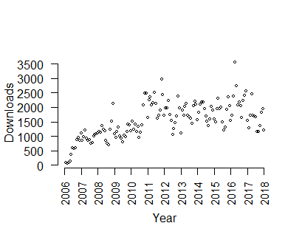

Figure 1: Download vs Date scatterplot

Plotting the lowess regression lines with different f values

plot(as.numeric(down$Date),down$Downloads,xaxt="n",bty="n",pch=21,cex=.5,type="p",las=1,  
 ylab="Downloads",xlab="Year")  
axis(1,0:12*12,2006:2018,las=3,cex.axis=.95)  
lines(lowess(down$Downloads~down$MonthNumber, f=0.10), col="red")  
lines(lowess(down$Downloads~down$MonthNumber, f=0.25), col="green")  
lines(lowess(down$Downloads~down$MonthNumber, f=0.50), col="blue")  
lines(lowess(down$Downloads~down$MonthNumber, f=0.01), col="purple")  
lines(lowess(down$Downloads~down$MonthNumber, f=0.05), col="gold")

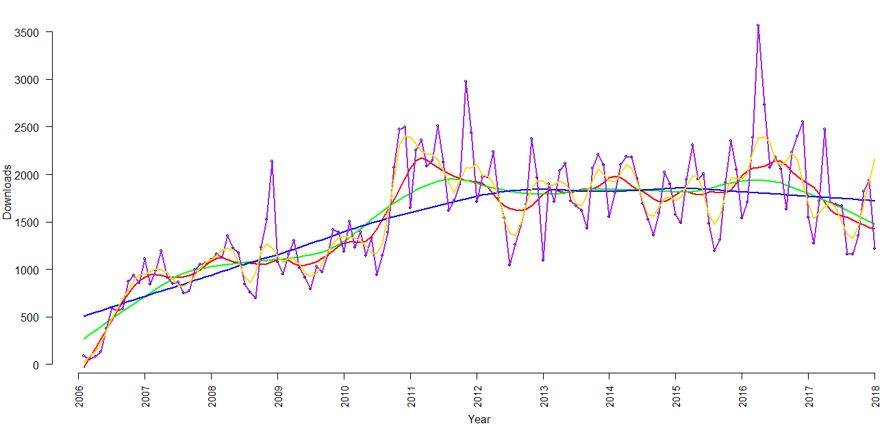

Figure 2: Lowess regression with different f values

Firstly, I plotted the regression lines with the lowess function where I changed the f values. In the above plot we see that the purple line is overfitting the data points which has f=0.01 and our best estimate here is the red line with f=0.1 so we see here that when f value is low the model is over fitted and when its high the model is under fitted so we have to choose a value which fits the model best which here in this case is the red line, f=0.1

Now plotting the loess regression lines with different span values

plot(as.numeric(down$Date),down$Downloads,xaxt="n",bty="n",pch=21,cex=.5,type="p",las=1,  
 ylab="Downloads",xlab="Year")  
axis(1,0:12*12,2006:2018,las=3,cex.axis=.95)  
  
lmodel <- loess(down$Downloads~down$MonthNumber)  
xs <- 0:50000/100  
points(xs,predict(lmodel,xs),type="l",col="red",lwd=2)  
summary(lmodel)

## Call:  
## loess(formula = down$Downloads ~ down$MonthNumber)  
##   
## Number of Observations: 144   
## Equivalent Number of Parameters: 4.34   
## Residual Standard Error: 405.6   
## Trace of smoother matrix: 4.73 (exact)  
##   
## Control settings:  
## span : 0.75   
## degree : 2   
## family : gaussian  
## surface : interpolate cell = 0.2  
## normalize: TRUE  
## parametric: FALSE  
## drop.square: FALSE

print(paste("lmodel R^2:", cor(down$Downloads,predict(lmodel))^2))

## [1] "lmodel R^2: 0.567812171532501"

We here have span = 0.75 and R2 = 0.56 and RSE = 405.6

lmodel2 <- loess(down$Downloads~down$MonthNumber,span=.2,degree = 2)  
points(xs,predict(lmodel2,xs),type="l",col="green",lwd=2)  
summary(lmodel2)

## Call:  
## loess(formula = down$Downloads ~ down$MonthNumber, span = 0.2,   
## degree = 2)  
##   
## Number of Observations: 144   
## Equivalent Number of Parameters: 14.98   
## Residual Standard Error: 351.1   
## Trace of smoother matrix: 16.57 (exact)  
##   
## Control settings:  
## span : 0.2   
## degree : 2   
## family : gaussian  
## surface : interpolate cell = 0.2  
## normalize: TRUE  
## parametric: FALSE  
## drop.square: FALSE

print(paste("lmodel2 R^2:", cor(down$Downloads,predict(lmodel2))^2))

## [1] "lmodel2 R^2: 0.706344969156763"

We here have span = 0.2 and R2 = 0.706 and RSE = 351.1

lmodel3 <- loess(down$Downloads~down$MonthNumber,span=.3)  
points(xs,predict(lmodel3,xs),type="l",col="navy",lwd=2)  
summary(lmodel3)

## Call:  
## loess(formula = down$Downloads ~ down$MonthNumber, span = 0.3)  
##   
## Number of Observations: 144   
## Equivalent Number of Parameters: 10.19   
## Residual Standard Error: 358.9   
## Trace of smoother matrix: 11.26 (exact)  
##   
## Control settings:  
## span : 0.3   
## degree : 2   
## family : gaussian  
## surface : interpolate cell = 0.2  
## normalize: TRUE  
## parametric: FALSE  
## drop.square: FALSE

print(paste("lmodel3 R^2:", cor(down$Downloads,predict(lmodel3))^2))

## [1] "lmodel3 R^2: 0.678958327747172"

We here have span = 0.3 and R2 = 0.678 and RSE = 358.9

lmodel4 <- loess(down$Downloads~down$MonthNumber,span=.4)  
points(xs,predict(lmodel4,xs),type="l",col="gold",lwd=2)

summary(lmodel4)

## Call:  
## loess(formula = down$Downloads ~ down$MonthNumber, span = 0.4)  
##   
## Number of Observations: 144   
## Equivalent Number of Parameters: 7.71   
## Residual Standard Error: 365.4   
## Trace of smoother matrix: 8.5 (exact)  
##   
## Control settings:  
## span : 0.4   
## degree : 2   
## family : gaussian  
## surface : interpolate cell = 0.2  
## normalize: TRUE  
## parametric: FALSE  
## drop.square: FALSE

print(paste("lmodel4 R^2:", cor(down$Downloads,predict(lmodel4))^2))

## [1] "lmodel4 R^2: 0.660427690680401"

We here have span = 0.4 and R2 = 0.66 and RSE = 365.4

We see from the above results that the R2 value is highest for lmodel2 where R2 = 0.706. So the most reasonable span parameter is 0.2

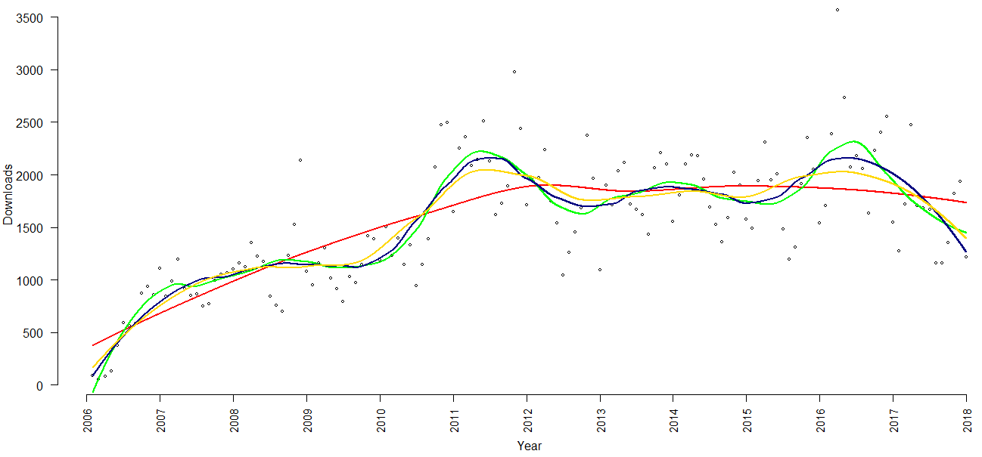

Figure 3:Loess regression lines with different span values

We plotted all the loess regression lines to the main plot and as we concluded that span = 0.2 is the best span estimate and we can validate it easily from Fig. 3 where span = 0.2 is the green line and it fits the model best as compared to other loess regression lines.

## B. Polynomial regression

Plotting MonthNumber vs Downloads and drawing the loess regression line

down <- read.csv("DownloadData.csv")  
down$Month <- as.factor(substr(down$Date,6,8))  
down$MonthNumber <- 1:nrow(down)  
plot(down$MonthNumber,down$Downloads,xaxt="n",bty="n",pch=21,cex=.5,type="p",las=1,  
 ylab="Downloads",xlab="Year")  
axis(1,0:12*12,2006:2018,las=3,cex.axis=.95)  
  
  
lines(lowess(down$Downloads~down$MonthNumber))

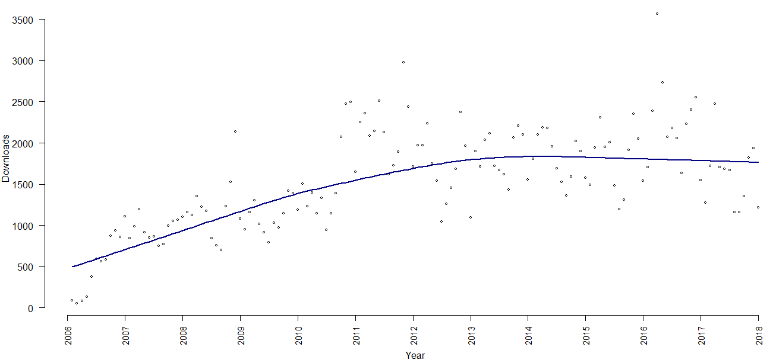

Figure 4:Plotting MonthNumber vs Downloads and drawing the loess regression line

Creating the polynomial regression with the poly() function

poly1 <- lm(Downloads ~ poly(MonthNumber, 1), data = down)  
poly2 <- lm(Downloads ~ poly(MonthNumber, 2), data = down)  
poly3 <- lm(Downloads ~ poly(MonthNumber, 3), data = down)  
poly4 <- lm(Downloads ~ poly(MonthNumber, 4), data = down)  
poly5 <- lm(Downloads ~ poly(MonthNumber, 5), data = down)

Using AIC to determine the best model

data.frame(model = paste ("lm" ,1:5 , sep =""),  
 rbind ( extractAIC ( poly1 ),  
 extractAIC ( poly2 ),  
 extractAIC ( poly3 ),  
 extractAIC ( poly4 ),  
 extractAIC ( poly5 )))

## model X1 X2  
## 1 lm1 2 1774.614  
## 2 lm2 3 1733.811  
## 3 lm3 4 1735.810  
## 4 lm4 5 1737.027  
## 5 lm5 6 1738.086

We see that the AIC values decrease till lm2 and then again increases so lm2 is the best model from the results of AIC.

Now, checking with the results of BIC

extractBIC <- function (model)  
{  
 extractAIC (model ,k= log ( length ( model $ residuals )))  
}  
  
data.frame( model = paste ("lm" ,1:5 , sep =""),  
 rbind ( extractBIC ( poly1 ),  
 extractBIC ( poly2 ),  
 extractBIC ( poly3 ),  
 extractBIC ( poly4 ),  
 extractBIC ( poly5 )))

## model X1 X2  
## 1 lm1 2 1780.554  
## 2 lm2 3 1742.721  
## 3 lm3 4 1747.690  
## 4 lm4 5 1751.876  
## 5 lm5 6 1755.905

We see here as well that the BIC values decrease till lm2 and then again increases so lm2 is the best model from the results of BIC as well.

summary(poly2)

##   
## Call:  
## lm(formula = Downloads ~ poly(MonthNumber, 2), data = down)  
##   
## Residuals:  
## Min 1Q Median 3Q Max   
## -807.14 -299.35 -2.19 202.95 1685.16   
##   
## Coefficients:  
## Estimate Std. Error t value Pr(>|t|)   
## (Intercept) 1541.67 33.95 45.406 < 2e-16 ***  
## poly(MonthNumber, 2)1 4616.69 407.43 11.331 < 2e-16 ***  
## poly(MonthNumber, 2)2 -2846.36 407.43 -6.986 1.03e-10 ***  
## ---  
## Signif. codes: 0 '***' 0.001 '**' 0.01 '*' 0.05 '.' 0.1 ' ' 1  
##   
## Residual standard error: 407.4 on 141 degrees of freedom  
## Multiple R-squared: 0.5569, Adjusted R-squared: 0.5506   
## F-statistic: 88.6 on 2 and 141 DF, p-value: < 2.2e-16

pred<-predict(poly2)  
  
plot(down$MonthNumber,down$Downloads)  
lines(down$MonthNumber,y=pred,col="red")

Comparing both the results

plot(down$MonthNumber,down$Downloads,xlab = "Month Number",ylab = "Downloads")

lmodel2 <- loess(down$Downloads~down$MonthNumber,span=.2,degree = 2)

points(xs,predict(lmodel2,xs),type="l",col="green",lwd=2)

summary(lmodel2)

print(paste("lmodel2 R^2:", cor(down$Downloads,predict(lmodel2))^2))

## [1] "lmodel2 R^2: 0.706344969156763"

poly2 <- lm(Downloads ~ poly(MonthNumber, 2), data = down)

summary(poly2)

pred<-predict(poly2)

lines(down$MonthNumber,y=pred,col="red",lwd=2)

## Call:

## lm(formula = Downloads ~ poly(MonthNumber, 2), data = down)

##

## Residuals:

## Min 1Q Median 3Q Max

## -807.14 -299.35 -2.19 202.95 1685.16

##

## Coefficients:

## Estimate Std. Error t value Pr(>|t|)

## (Intercept) 1541.67 33.95 45.406 < 2e-16 ***

## poly(MonthNumber, 2)1 4616.69 407.43 11.331 < 2e-16 ***

## poly(MonthNumber, 2)2 -2846.36 407.43 -6.986 1.03e-10 ***

## ---

## Signif. codes: 0 ‘***’ 0.001 ‘**’ 0.01 ‘*’ 0.05 ‘.’ 0.1 ‘ ’ 1

##

## Residual standard error: 407.4 on 141 degrees of freedom

## Multiple R-squared: 0.5569, Adjusted R-squared: 0.5506

## F-statistic: 88.6 on 2 and 141 DF, p-value: < 2.2e-16

We here have span = 0.2 and R2 = 0.706 and RSE = 351.1 for loess regression whereas we have the R2 = 0.5506 and RSE = 407.4 for poly() so we can conclude that the loess regression line fits the model better because it has the greater R2 value.

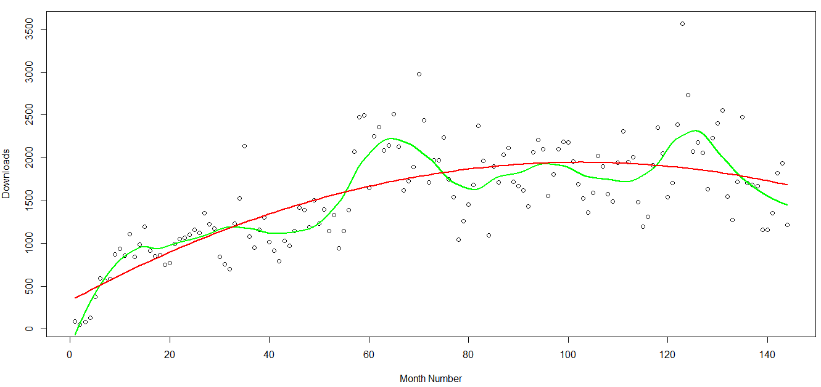

Figure 5: Comparing loess and poly()

We can verify our conclusion from the above plot the loess regression line(green) fits the model better than ploy()(red).

## C. Adding month predictor

fit3 <- lm(Downloads ~ poly(MonthNumber,2)+as.factor(Month)+0, data = down)   
pred<-predict(fit3)

We added month predictor to the poly function with degree 2 which was the best model as we saw the results of AIC and BIC. Also we added the 0 intercept so that each month has unique values

fit3

##   
## Call:  
## lm(formula = Downloads ~ poly(MonthNumber, 2) + as.factor(Month) +   
## 0, data = down)  
##   
## Coefficients:  
## poly(MonthNumber, 2)1 poly(MonthNumber, 2)2 as.factor(Month)01   
## 4620 -2851 1466   
## as.factor(Month)02 as.factor(Month)03 as.factor(Month)04   
## 1605 1884 1606   
## as.factor(Month)05 as.factor(Month)06 as.factor(Month)07   
## 1524 1327 1215   
## as.factor(Month)08 as.factor(Month)09 as.factor(Month)10   
## 1193 1563 1931   
## as.factor(Month)11 as.factor(Month)12   
##

We can see that all the 12 months have a unique value.

summary(fit3)

##   
## Call:  
## lm(formula = Downloads ~ poly(MonthNumber, 2) + as.factor(Month) +   
## 0, data = down)  
##   
## Residuals:  
## Min 1Q Median 3Q Max   
## -684.79 -226.71 -53.08 180.43 1342.22   
##   
## Coefficients:  
## Estimate Std. Error t value Pr(>|t|)   
## poly(MonthNumber, 2)1 4620.13 338.96 13.63 < 2e-16 ***  
## poly(MonthNumber, 2)2 -2851.11 337.80 -8.44 5.36e-14 ***  
## as.factor(Month)01 1466.43 97.58 15.03 < 2e-16 ***  
## as.factor(Month)02 1605.46 97.56 16.46 < 2e-16 ***  
## as.factor(Month)03 1884.47 97.54 19.32 < 2e-16 ***  
## as.factor(Month)04 1606.12 97.53 16.47 < 2e-16 ***  
## as.factor(Month)05 1523.82 97.52 15.63 < 2e-16 ***  
## as.factor(Month)06 1327.17 97.51 13.61 < 2e-16 ***  
## as.factor(Month)07 1215.49 97.51 12.46 < 2e-16 ***  
## as.factor(Month)08 1193.20 97.52 12.24 < 2e-16 ***  
## as.factor(Month)09 1562.97 97.53 16.03 < 2e-16 ***  
## as.factor(Month)10 1931.13 97.54 19.80 < 2e-16 ***  
## as.factor(Month)11 1867.27 97.56 19.14 < 2e-16 ***  
## as.factor(Month)12 1316.46 97.58 13.49 < 2e-16 ***  
## ---  
## Signif. codes: 0 '***' 0.001 '**' 0.01 '*' 0.05 '.' 0.1 ' ' 1  
##   
## Residual standard error: 337.8 on 130 degrees of freedom  
## Multiple R-squared: 0.9625, Adjusted R-squared: 0.9584   
## F-statistic

plot(down$MonthNumber,down$Downloads)  
lines(down$MonthNumber,y=pred,col="red")

lmodel2 <- loess(down$Downloads~down$MonthNumber,span=.2,degree = 2)

points(xs,predict(lmodel2,xs),type="l",col="green",lwd=2)

poly2 <- lm(Downloads ~ poly(MonthNumber, 2), data = down)

pred<-predict(poly2)

lines(down$MonthNumber,y=pred,col="navy",lwd=2)

|  |  |  |  |
| --- | --- | --- | --- |
| Models | Loess regression | Poly() | +0 intercept |
| R2 | 0.706 | 0.5506 | 0.9584 |

We see here that the R2 value is highest for our model with +0 intercept so we can say that it best fits our model.

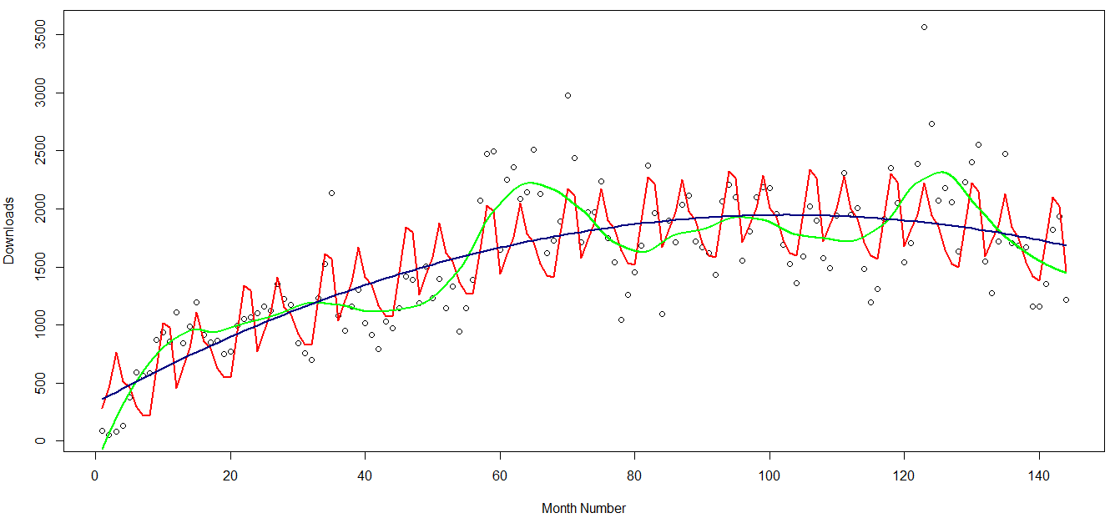

Figure 6: Comparison of all 3 best models

On comparing loess(green), poly() (blue) and +0 intercept(red) we see that this model is fitting the values better than the other 2 models.